**ROCO507Z** **Advanced Robot Design & Prototyping: Project Proposal**

**Title:** Monowheel Robot

**Team Members:**

Yasas Chandrasena (10940925)

Sudeera Milakshan (10948185) Puranjana Wijayarathna (10942674)

Tanvibahen Lakhani (10937718)

Himeth Sanjula (10749155)

**Overview:**

Our project will explore the development and implementation of a robotic system for a monowheel robot. This robot has the capability of balancing itself on a single wheel while driving on various surfaces along with the ability to jump. This robot can be used for surveillance purposes, military purposes, agricultural purposes and also for further research.

**Theoretical Concept:**

The proposed single-wheel robot employs a two-axis stabilization system to maintain balance. Along the y-axis, it dynamically adjusts its center of gravity through limb movements, while x-axis stability is achieved using a reaction wheel to counteract momentum. By leveraging the reaction forces from limb movements, the robot can perform jumping actions. Directional control is accomplished by generating reaction forces with the reaction wheel.

**AI Concept:**

To balance the robot, the system calculates the required counter-momentum and applies it to the reaction wheel. This process is managed by an AI model, potentially utilizing Reinforcement Learning, Recurrent Neural Networks, Long Short-Term Memory, or a Convolutional Neural Network. The chosen model continuously analyzes data from the Inertial Measurement Unit (IMU), learning in real-time to determine the precise force needed for stabilization. This adaptive approach allows the robot to maintain balance efficiently across various conditions, adjusting its response based on immediate feedback and accumulated experience. Computer vision models such as yolo, resnet or imagenet will be integrated for step detection if time permits.

**Components:**

IMU, Raspberry Pi (main controller), Arduino Nano/ ESP 32 (initial controller), Servo motor/ Stepper motor (for limb movement), Servo/ Stepper motor drivers, brushless DC motor with encoder (drive wheel), Stepper motor (reaction wheel), Stereo/ 3D camera.

**Initial 3D Design:**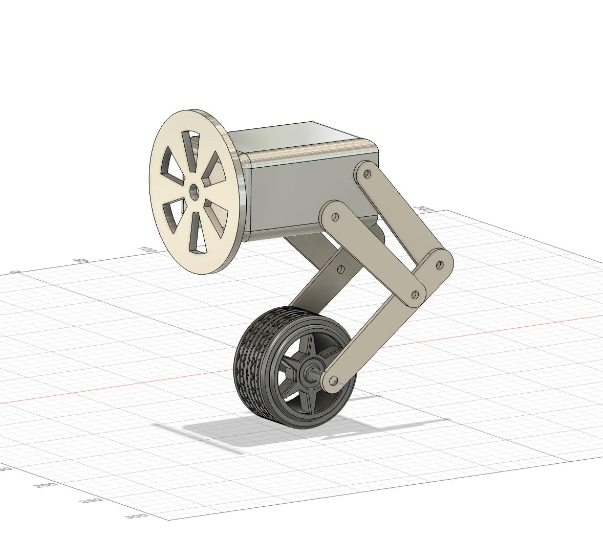



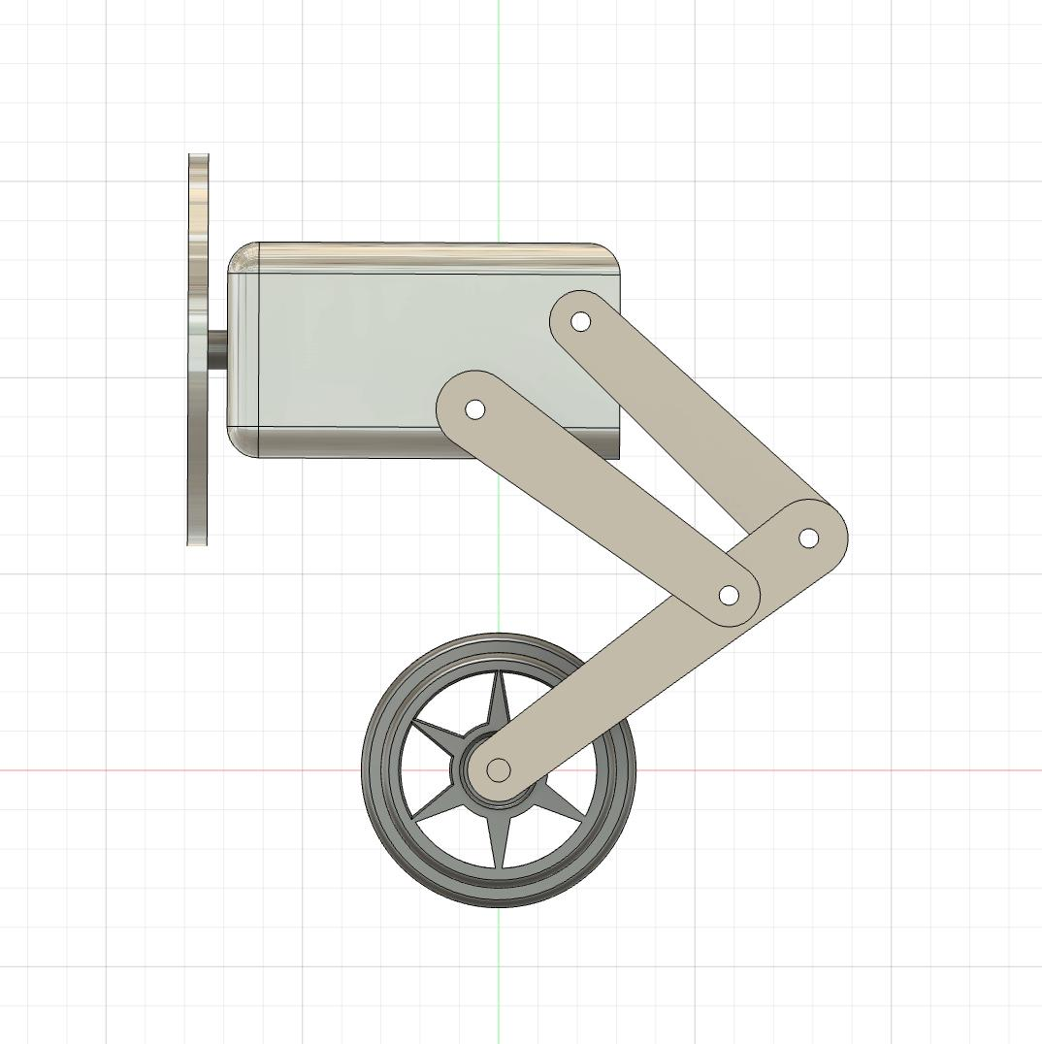



**References:**

[1] J. Lee, S. Han, and J. Lee, “Decoupled Dynamic Control for Pitch and Roll Axes of the Unicycle Robot,” *IEEE Transactions on Industrial Electronics*, vol. 60, no. 9, pp. 3814-3822, Sept. 2013, doi: 10.1109/TIE.2012.2208431.

[2] D. B. Tank, R. S. Jo, and H. S. Jo, “Dynamic Modelling and Control of Self-Balancing One-Legged Robot,” in *2018 IEEE International Conference on Automatic Control and Intelligent Systems (I2CACIS)*, Shah Alam, Malaysia, Oct. 2018, doi: 10.1109/I2CACIS.2018.8603694.